**`**

**QUALIFICATION TEST PROCEDURE**

**FOR**

**“MONITOR WITH FOLDABLE KBD AND TRACKBALL”**

**(BEL Part No: - 4461 723 101 86)**

|  |  |  |  |
| --- | --- | --- | --- |
| **P.O. No.** | **BEPO/HD4/4000071885** | **DATED:** | ***17th NOVEMBER 2016*** |
| **PREPARED BY.** | **PURUSHOTHAM REDDY** | **APPROVED BY** | **Mr**. **RAJMOHAN. K** |
| **SIGNATURE.** |  | **SIGNATURE.** |  |
| **BEL (Rep) NAME** | **Mr**. | **APPROVED BY.** | **Mr**. |
| **SIGNATURE.** |  | **SIGNATURE.** |  |

**SUPPLIED TO:**



**M/S BHARAT ELECTRONICS LIMITED,**

**HYDERABAD – 560 076.**

**MANUFACTURED BY:**



**M/S DATASOL (B) PVT. LTD,**

**BANGALORE – 560 045.**

**TABLE OF CONTENTS**

|  |  |  |
| --- | --- | --- |
|  | **DESCRIPTION** | **PAGE NO** |
| **1.0** | **SCOPE** | 3 |
| **1.1** | **IDENTIFICATION** |  |
| **1.2** | **System Overview** |  |
| **2.0** | **Specifications** |  |
| **3.0** | **Test Equipment Required** |  |
| **4.0** | **Physical Inspection** |  |
| **5.0** | **Functional Test Procedure** |  |
| **6.0** | **ESS Test Specification** |  |
| **7.0** | **Qualification Test Specifications** |  |
| **7.1** | **Vibration (Endurance)** |  |
| **7.2** | **High Temperature Operational** |  |
| **7.3** | **High Temperature Storage** |  |
| **7.4** | **Damp Heat** |  |
| **7.5** | **Low Temperature Test operational** |  |
| **7.6** | **Low Temperature Test Storage** |  |
| **7.7** | **Altitude test** |  |
| **7.8** | **Temperature Cycling** |  |
| **7.9** | **Drop Test** |  |
| **7.10** | **Toppling Test** |  |
| **7.11** | **Bump Test** |  |
| **8.0** | **EMI / EMC Test Specifications** |  |
| **8.1** | **CE102, Conducted Emissions, Power Leads, 10KHz TO 10MHz** |  |
| **8.2** | **CS101, Conducted Susceptibility, Power leads 30 Hz to 150 KHz** |  |
| **8.3** | **CS114, Conducted Susceptibility, Bulk Cable Injection,10K Hz to 20M Hz** |  |
| **8.4** | **CS115, Conducted Susceptibility, Bulk Cable Injection, Impulse Excitation** |  |
| **8.5** | **CS116, Damped sinusoidal transients, cables and power leads,10KHz to 100MHz** |  |
| **8.6** | **RE102, Radiated Emission, Electric Field, 10KHz TO 18G Hz** |  |
| **8.7** | **RS103, Radiated Susceptibility, Electric field,2M Hz to 40G Hz** |  |
|  | **Physical Test Report-TDR-1** |  |
|  | **Functional Test Report - TDR-2** |  |
|  |  |  |

**1.0 SCOPE**

This document defines the procedure that is to be followed during the process of Qualification of the

17”RUGGED MONITOR WITH FOLDABLE KEYBOARD AND TRACKER BALL for fulfilling the needs of BEL Hyderabad, as per the Purchase Order.

* 1. **IDENTIFICATION**

The 17” Rugged Monitor With Foldable Keyboard and Tracker Ball supplied by M/S Datasol to M/S

Bharat Electronics Limited will be here after identified as given below.

Name : 17”Rugged Monitor With Foldable Keyboard and Tracker Ball

Identification Number : DBPL-17RDKBDT

BEL Part Number : 4461 723 101 86

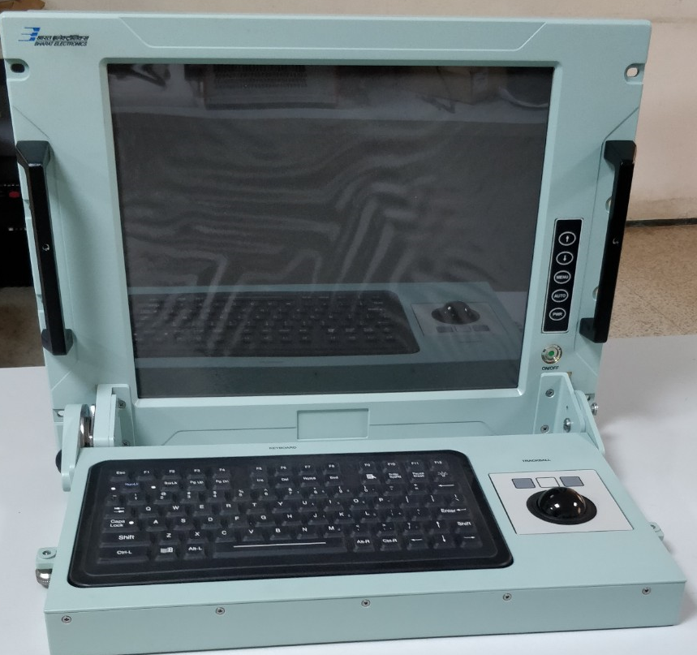

**VIEW OF DBPL-17RDKBDT**

**1.2 System Overview**

17RDKBDT is a 17” Rack mount unit with Built-in 17” LCD flat panel monitor built specifically for

industrial applications, Panel Mount Compact Back-light keyboard and 38mm Tracker Ball. It is an

excellent and user-friendly system control interface with Built-in keyboard, video and mouse

(KVM). In addition to its usual application as an LCD panel monitor, 17RDKBDT comes standard

with DVI control signal inputs, making it compatible with Industrial PCs, Workstations and USB

Interfaces for the Keyboard and Tracker Ball.

17RDKBDT is providing the Human Machine Interface to the Missile Systems. It is built for spacelimited environments with high graphics demand.

**2.0: Specifications**

* ➢ **Construction:** Heavy duty Aluminum alloy
* ➢ **Front panel Control:** OSD control keypad
* ➢ **Mounting:** 17” Rack mountable
* ➢ **Connection:** Key Board, Tracker Ball, AC Input, VGA , DVI Connector
* ➢ **Display:** 17” with resolution 1280 X 1024
* ➢ **Dimensions (W x H x D):** Details in TDR-1
* ➢ **Weight:** < 13 Kgs

**Model :** DBPL-17RDKBDT

**Size :** 17” Monitor with Foldable Keyboard and Tracker ball

**Construction :** Aluminium Alloy

**Weight :** 13 kg Aprox

**Keyboard :** Panel Mount, 88 Keys Keyboard with Integrated Backlight

Completely sealed NEMA 4X Casing

**Tracker Ball :** Panel Mount, 38mm Phenolic Resin Black fully sealed

**Power Supply :** Industrial Level AC 100 / 240 V Auto Switching

**Interface :** Circular VGA Connector

Standard DVI Connector

Power through Circular Connector

Separate Circular connectors for Keyboard and Track Ball Interface

One Fuse Holder

One Ground Stud

**3.0: Test Equipment Required:**

CPU of a standard PC - 1 No

Circular Power cables - 1 Nos.

Circular Video cable - 1 No.

Circular DVI cable -1 No

Circular USB Cables - 2 Nos.

Power chord -1 No

**4.0: Physical Inspection**

1.Check the Display for any damages

2. Check if the power circular connector is properly mating at the Display end and also clearly inserted at the power socket.

3. Check all the connectors, power & signal for any loose pins/wires.

4. Check the measurements as specified in TDR-1 and note down the result in TDR-1.

**5.0: Functional Test Procedure:**

1. Connect the Display to the CPU of a PC. After switching ON the power to Display check the system booting and display seen on the screen of Display.

1. Connect the Tracker ball and Keyboard cables from the CPU to Test PC

3.Check the functionality of the keyboard by typing &Tack ball by right clicking / scrolling the ball.

4. Note down the results in TDR-2.

5. After checking, shutdown the system and switch off the Display Unit.

**6.0: ESS Test Specification As Per MIL STD- 810E**

|  |  |  |  |
| --- | --- | --- | --- |
| **S.No** | **Parameter** | **Test Description** | **Remarks** |
| 1 | Random vibration-pre  Thermal cycling | 20Hz-80Hz , sloping at +3dB/octave:  80Hz to 350Hz, 0.02 g2/Hz PSD, 350-2000Hz, sloping at  -3dB/octave.  5min. per axis on all three axes. |  |
| 2 | Thermal cycling | -10° C to +55° C  Dwell AT -10° C and +55° C for 1 hour.  No.of cycles:10  Rate of cooling/heating: 5° C /minute |  |
| 3 | Random vibration post Thermal cycling | 20Hz-80Hz , sloping at +3dB/octave:  80Hz to 350Hz, 0.02 g2/Hz PSD, 350-2000Hz, sloping at  -3dB/octave.  5Min.per axis on all three axes. |  |

**7.0: Qualification Test Specifications:**

**Reference Std: JSS 55555:2000, L2(H) classification for partially protected units mounted in vehicles. All the Qualification tests are to be conducted at approved test facilities only.**

|  |  |  |  |
| --- | --- | --- | --- |
| **S.No** | **Type of Test** | **Specifications** | **Duration** |
| 7.1 | Vibration (Endurance)  (i) 5 to 8 Hz  (ii) 8 to500Hz | Test No28 table 4.28.2 S.No.1(b) Amplitude  ± 6 mm constant displacement  ± 15 m/s² Constant acceleration (1.5g) | 1 hour in each axis |
| 7.2 | High Temp Operational | Test No 17, procedure 6,  Test Condition M 55ºC ± 3ºC | 16 hours |
| 7.3 | High Temp Storage | Test No 17, procedure 6,  Test Condition M 70ºC ± 3ºC | 16 hours |
| 7.4 | Damp Heat | Test No.10  40ºC±2ºC, 95% RH | 16 hours |
| 7.5 | Low Temp Test operational | Test No.20, procedure 4,  Test condition H -10ºC ± 3ºC | 16 hours |
| 7.6 | Low Temp Test Storage | Test No.20, procedure 4,  Test condition J -20ºC ± 3ºC | 16 hours |
| 7.7 | Altitude test  (a)Temp  (b)Height | Test No.3, Procedure 5, Condition A2 at -10ºC ± 3ºC  4160 M | 16 hours |
| 7.8 | Temp. Cycling | Test No.22, Procedure 2  At 55ºC±3ºC, 95% RH for 45 Min & At -10ºC±3ºC, for 45 Min  Such 04 cycles. | -- |
| 7.9 | Drop Test | Test Condition C  Face drop from a height of 25mm total 06 drops | Packed Condition |
| 7.10 | Toppling Test | Total 04 times dropped on each face on which the chassis of the equipment could be practicably paced during servicing. | Packed Condition |
| 7.11 | Bump Test | At 40g, total 500 Bumps @ 2-3 bumps/min | |  | | --- | | BUMP is recommended with carry case, since Display is involved. | |

**7.0: Qualification Test Procedure :**

**7.1: Vibration (Endurance)**

**Purpose**

This test is performed to determine if test items can be operated under severe physical dynamic condition without experiencing physical damage or deterioration in performance.

**Test Objectives**

The primary objective of the test is to determine whether:-

* + - * The basic design is adequate to withstand the specification requirement.
      * Design modifications are necessary to make it withstand the test severities.
      * Incorporation of isolation mechanism required in the event of inadequacies due to constraints in the design to make it functional under the severe dynamic conditions.

|  |  |
| --- | --- |
| **Test Specification:** | |
| **Vibration** | Sinusoidal sweep vibration:  5 to 8 Hz : ±6 mm constant displacement  8 to 500 Hz : ±1.5g constant acceleration  Sweep rate:1 oct/min  Equipment will be in ON condition (only power ON LED will glow).  Test duration: 1 hour in each X,Y&Z axis. |

**Test Procedure**

Step 1-Mount the test item with its fixture on the vibration table.

Step 2-Expose the test item in ‘unpacked’ and ‘switched-on’ condition to the Vibration test level and duration as specified.

Step 3-Repeat steps 2 & 3 for each axis.

**Final Measurements**

The equipment shall be visually examined and shall be electrically checked as specified and record the results in TDR-2

### **7.2:** **High Temperature Operational**

**Purpose**

High temperature operational test is performed to determine if test items can be operated under hot environmental conditions without experiencing physical damage or deterioration in performance.

**Test Objectives**

The primary objectives of the High Temperature test are to determine if:-

* + - The test item will operate without degradation after storage in a climatic which induces high temperature within the test item.
    - The test item can be operated and handled without affecting its integrity in a high temperature climate.
    - The test item is safe during and following high temperature exposure

|  |  |
| --- | --- |
| **Operational** | |
| Temperature | +55° C ±3 C |
| Duration | 16 hours |
| Condition | K |

**Test Procedure for** **Operational**

Step 1 - With the test item placed in the chamber in its ‘unpacked’ and ‘switched-on’ condition, adjust the chamber air conditions to the specified operational test temperature level of 550C.

Step 2 - Expose the test item to this temperature level till the stability is attained and then maintain for applicable hours.

Step 3 - Performance test the item and carryout operational check outs at 550C during last 1 hour of the conditioning period and record the results in the TDR-2.

Step 4 - Switch off the test item and adjust the chamber air temperature to standard laboratory ambient and maintain until temperature stabilization of the test item has been achieved.

Step 5 - Conduct a complete visual examination of the test item and

Step 6 - Conduct an operational checkout at ambient temperature.

**Final Measurements**

The equipment shall be visually examined and shall be electrically checked as specified and record the results in TDR-2

**7.3: High Temperature Storage**

**Purpose**

|  |  |
| --- | --- |
| **Storage** | |
| Temperature | +70° C ±3° C |
| Duration | 16 hours |
| Condition | K |

High temperature storage test is performed to determine if test items can be operated under hot environmental conditions without experiencing physical damage or deterioration in performance.

**Test Procedure for High Temperature Storage**

Step 1 -With the test item placed in the chamber in its ‘unpacked’ and ‘switched-off’ condition, adjust the chamber air conditions to the specified storage of 700C for applicable hours.

Step 2 -At the end of the test adjust the chamber air temperature to ambient conditions and bring down the temperature. Maintain until temperature stabilization of the test item has been achieved.

**Final Measurements**

The equipment shall be visually examined and shall be electrically checked as specified and record the results in TDR-2

**7.4: Damp Heat**

**Objective**

To determine the suitability of electronic and electrical equipment for use under conditions of high humidity.

|  |  |
| --- | --- |
| **Specifications** | |
| Temperature | +40° C ±2° C |
| Duration | 16 hours |
| RH Value | 95 ± 3 % |

**Conditioning**

Step1: The equipment under test shall be subjected to the test in its' unpacked' and 'switched-off' condition.

Step2: The equipment under test, while being under the laboratory atmospheric conditions shall be introduced into the chamber, the latter also being under the same conditions. The temperature and relative humidity of the chamber shall then be raised to 40ºC ± 2 ºC and not less than 95 percent respectively, over a period of not less than one hour.

Step3: The equipment shall be conditioned under these conditions for a period of 16 hours.

Step4: During the last 30 minutes of the period, the equipment shall be switched on and a performance check, as specified, shall be carried out.

Step5: The temperature of the chamber shall then be restored to the laboratory atmospheric conditions in not less than an hour. Saturation of the chamber atmosphere with water vapor shall occur during this period. The equipment shall then be exposed to these conditions for a period of not less than 3 hours.

**Recovery**

The equipment shall be recovered from the chamber and shall be allowed to remain under standard recovery conditions for a period of 2 to 4 hours.

**Final Measurements**

The equipment shall be visually examined and shall be electrically checked as specified and record the results in TDR-2

**7.5: Low Temperature Operational**

**Purpose**

Low temperature chamber tests are performed to determine if material can be stored, manipulated, and operated under pertinent low temperature conditions without experiencing physical damage or deterioration in performance.

**Test Objectives**

The primary objectives of the low temperature test are to determine if:

1.The test item can meet the performance specifications during operation in a cold environment.

2. The test item can be operated safely during or following low temperature exposure.

**Test Specification**

|  |  |
| --- | --- |
| Operational | |
| Temperature | -10° C ±3° C |
| Duration | 16 hours |
| Condition | H |

**Test Procedure for Low Temperature Operational**

Step1: With the test item placed in the chamber in its ‘unpacked’ and ‘switched-on’ condition, adjust the chamber air conditions to the specified operational test temperature of -100C. Maintain until temperature stabilization of the test item has been achieved and soak the equipment for applicable hours.

Step 2: Conduct an operational checkout of the test item after soaking period during last 1 hour.

Step 3: Switch off the test item and adjust the chamber air temperature to standard laboratory ambient and maintain until temperature stabilization of the test item has been achieved.

**Final Measurements**

The equipment shall be visually examined and shall be electrically checked as specified and record the results in TDR-2

**7.6: Low Temperature Storage**

**Purpose**

Low temperature chamber tests are performed to determine if material can be stored, manipulated, and operated under pertinent low temperature conditions without experiencing physical damage or deterioration in performance.

**Test Specification**

|  |  |
| --- | --- |
| Storage | |
| Temperature | -20° C ±3° C |
| Duration | 16 hours |
| Condition | J |

**Test Procedure for Low Temperature Storage**

Step 1 - With the test item placed in the chamber in its ‘unpacked’ and ‘switched-off’ condition, adjust the chamber air conditions to the specified storage of -200C. Maintain until temperature stabilization of the test item has been achieved and soak the equipment for applicable hours. Step 2 - Conduct an operational checkout of the unit after the test or during the recovery

period and document the results.

**Final Measurements**

The equipment shall be visually examined and shall be electrically checked as specified and record the results in TDR-2

**7.7: Altitude**

**Objective**

To determine the suitability of electronic and electrical equipment for use under simultaneously applied Service conditions of low air pressure and high or low temperature.

**Test Chamber**

Step 1 - The altitude chamber shall be capable of maintaining its working space at the appropriate low air pressure severity within a tolerance of ± 5 percent. In addition, the chamber shall also be capable of meeting all the requirements specified for test chamber for the high temperature test and the low temperature test.

Step 2 - The altitude chamber shall also be capable of maintaining a relative humidity of not less than 95 percent as required for procedure 5.

**Conditioning**

The equipment under test shall be subjected to this test in 'unpacked' condition. The equipment shall be subjected to procedure 5 as specified. At the beginning of the procedure the equipment shall be in its 'switched-off' condition.

**Procedure 5**

Step 1 - The equipment under test, while being under laboratory atmospheric condition, shall be introduced into the chamber, the latter also being under the same conditions. The temperature of the chamber shall then be lowered to one of the following test conditions, as specified:

Step 2 - The air pressure inside the chamber shall then be reduced to a value corresponding to the test conditions, given in the Table 5 as specified.

* Test condition : -10ºC ± 3 deg C

|  |  |  |
| --- | --- | --- |
| **TEST CONDITION** | **ALTITUDE IN METRES** | **AIR PRESSURE IN kPa** |
| A2 | 4,160 | 60.0 |

**TEST CONDITIONS FOR ALTITUDE**

Step3 - The conditions of temperature and air pressure as specified in Step 1 and 2 shall be maintained for a period of 16 hours.

Step 4 - During the last 30 minutes of the period, the equipment shall be 'switched on' and a performance check shall be carried out, as specified.

Step 5 - The temperature of the chamber shall then be allowed to rise, at such a rate that it would attain laboratory atmospheric conditions in not less than one hour and not more than four hours.

Step 6 - When the equipment temperature has reached a value between 0 and 10o C, the air pressure inside the chamber shall be restored to laboratory atmospheric conditions within 30 minutes.

**Final Measurements**

The equipment shall be visually examined and shall be electrically checked as specified and record the results in TDR-2

**7.8: Temperature Cycling:**

The test item has to be subjected to the temperature extremes of -10°C and +55°C for four cycles. The rate-of-change of temperature should be from minimum to maximum and vice versa and change should be at an average rate of 5°C/min

In Thermal Cycling Test, there should be 4 cycles . In each cycle at At 55ºC±3ºC, 95% RH for 45 Min & At -10ºC±3ºC, for 45 Min.

**Final Measurements**

The equipment shall be visually examined and shall be electrically checked as specified and record the results in TDR-2

**7.9: Drop Test**

**Object**

To determine the ability of electronic and electrical equipment to withstand the shocks normally induced when it is dropped or roughly handled during its use.

**Conditioning**

1. The equipment under test shall be subjected to this test in its `unpacked' and `switched-off' condition.
2. The equipment shall be allowed to fall freely on the drop test platform
3. The height of drop is 6 Drops from a height of 25mm

**Final Measurements**

The equipment shall be visually examined and shall be electrically checked as specified and record the results in TDR-2

**7.10: Toppling Test**

**Object**

To determine the ability of electronic and electrical equipment to withstand the shocks encountered during servicing.

**Test Procedure**

* Total 04 times dropped in Packed condition and the lifted edges of the chassis has been raised 100 mm on each face.

**Final Measurements**

The equipment shall be visually examined and shall be electrically checked as specified and record the results in TDR-2

**7.11: Bump Test**

**Object**

To determine the ability of electronic and electrical equipment to withstand repeated bumps without malfunctioning and mechanical damage.

**Test Procedure**

* The specification of the test is 500 bumps at 40g 2 to 3 bumps/Min.

* Equipment, in its 'packed' and 'switched-off' conditions.

**Final Measurements**

The equipment shall be visually examined and shall be electrically checked as specified and record the results in TDR-2

**8.0: EMI / EMC Test Specifications As Per MIL-STD- 461E/F**

|  |  |  |  |  |
| --- | --- | --- | --- | --- |
| **SL.NO** | **Name Of Test** | **MIL Standard** | **Test Details** | **Remarks** |
| 8.1 | CE102 | MIL-STD- 461E | Conducted Emissions, Power Leads, 10KHz TO 10MHz |  |
| 8.2 | CS101 | MIL-STD- 461E | Conducted Susceptibility, Power leads 30 Hz to 150 KHz |  |
| 8.3 | CS114 | MIL-STD- 461E | Conducted Susceptibility, Bulk cable injection,10K Hz to 20M Hz, |  |
| 8.4 | CS115 | MIL-STD- 461E | Conducted Susceptibility, Bulk cable injection, impulse excitation |  |
| 8.5 | CS116 | MIL-STD- 461E | Damped sinusoidal transients, cables and power leads,10KHz to 100MHz . |  |
| 8.6 | RE102 | MIL-STD- 461E | Radiated Emission, Electric Field, 10KHz TO 18G Hz. |  |
| 8.7 | RS103 | MIL-STD- 461E | Radiated Susceptibility, Electric field,2M Hz to 40G Hz |  |

**8.0: EMI/EMC Test Procedures**

**8.1: CE102 Conducted Emissions, Power Leads, 10 kHz to 10 MHz**

**CE102 Applicability:**

This requirement is applicable from 10 kHz to 10 MHz for all power leads, including returns that obtain power from other sources not part of the EUT.

**CE102 Limit:**

The Limit curve shown below is the basic curve, 9dB relaxation is given for the EUT with 220 V voltage source. The limit curve will be 9dB elevated from as shown in Figure-1 Conducted emissions on power leads shall not exceed the applicable values shown on Figure - 1.

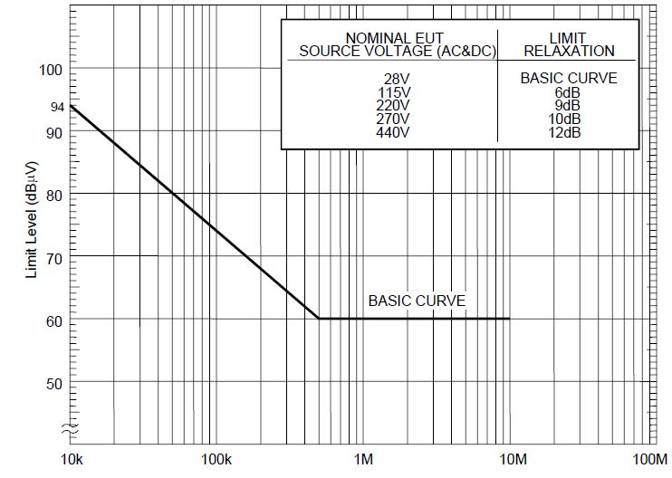

**Fig 1 CE102 Limit (EUT Power Leads, AC & DC)**

**CE102 Test Procedure:**

Perform emission data scans using the measurement setup given in Figure - 2

a) Perform Calibration as per MIL-STD-461E (CE102) Requirements

b) Turn on the EUT and allow a sufficient time for stabilization.

c) Select an appropriate lead for testing.

d) Scan the measurement receiver over the applicable frequency range.

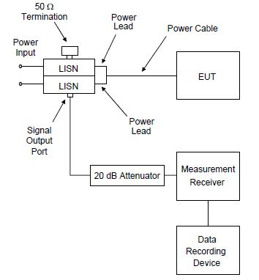

**Fig 2 CE 102 Measurement Setup**

**Final Measurements**

The equipment shall be visually examined and shall be electrically checked as specified and record the results in TDR-2

**8.2: CS101 Conducted Susceptibility, Power Leads, 30 Hz to 150 KHz**

**CS101 Applicability:**

This requirement is applicable to equipment and subsystem AC and DC input power leads, not including returns. If the EUT is DC operated, this requirement is applicable over the frequency range of 30 Hz to 150 kHz. If the EUT is AC operated, this requirement is applicable starting from the second harmonic of the EUT power frequency and extending to 150 kHz.

**CS101 Limits**:

The EUT shall not exhibit any malfunction, degradation of performance, or deviation from specified indications, beyond the tolerances indicated in the individual equipment or subsystem specification, when subjected to a test signal with voltage levels as specified in Figure 6.The requirement is also met when the power source is adjusted to dissipate the power level shown in Figure 7 in a 0.5-ohm load and the EUT is not susceptible.

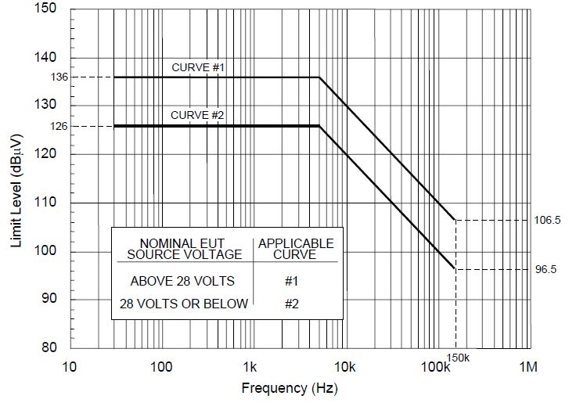

**Fig 6 CS101 Voltage Limit**

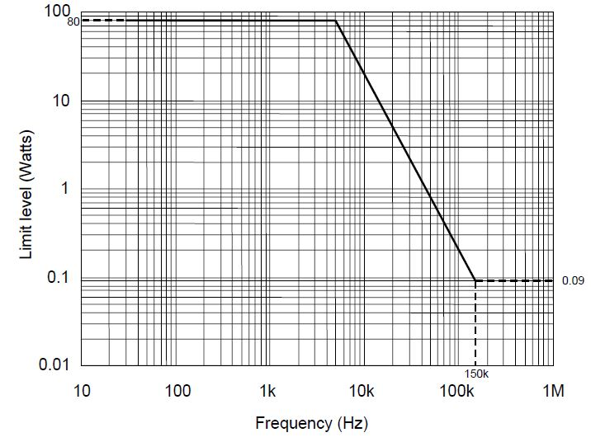

**Fig 7 CS102 Power Limit**

**CS101 Test Procedure:**

a) Perform Calibration as per MIL-STD-461E (CS101) Requirements

b) Turn on the EUT and allow a sufficient time for stabilization.

c) Set the signal generator to the lowest test frequency. Increase the signal level until

the required voltage or power level is reached on the power lead.   
d) While maintaining at least the required signal level, scan through the required frequency range at a rate no greater than specified in Susceptibility Test Parameters .

e) Susceptibility evaluation:

(i) Monitor the EUT for degradation of performance.

(ii) If susceptibility is noted, determine the threshold level and verify that it is above

the limit.

f) Repeat (c) through (e) for each power lead, as required.

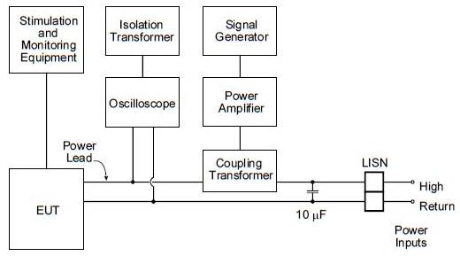

**Fig 8 CS101 Signal Injection Setup**

**Final Measurements**

The equipment shall be visually examined and shall be electrically checked as specified and record the results in TDR-2

**8.3: CS114 Conducted Susceptibility, Bulk Cable Injection, 10 kHz to 200 MHz.**

**CS114 Applicability:**

This requirement is applicable to all interconnecting cables, including power cables.

**CS114 Limit:**

The EUT shall not exhibit any malfunction, degradation of performance, or deviation from specified indications beyond the tolerances indicated in the individual equipment or subsystem specification, when subjected to a injection probe drive level which has been pre-calibrated to the appropriate current limit and is modulated as specified below. The appropriate limit curve given in Figure 9 shall be selected. Requirements are also met if the EUT is not susceptible at forward power levels sensed by the coupler that are below those determined during calibration provided that the actual current induced in the cable under test is 6 dB or greater than the calibration limit.

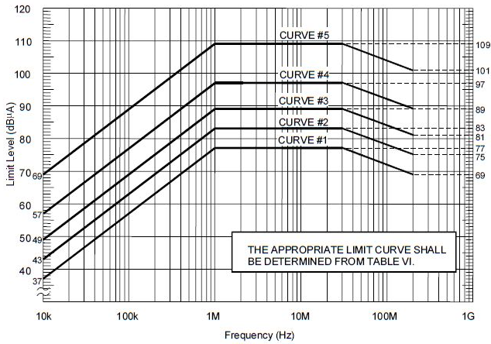

**Figure 9 : CS114 Calibration Limit for For All Applications**

**CS114 Test Procedure:**

a) Perform Calibration as per MIL-STD-461E (CS114) Requirements.

b) Turn on the EUT and allow a sufficient time for stabilization.

c) Susceptibility evaluation:

(i) Set the signal generator to 10 kHz with 1 kHz pulse modulation, 50% duty cycle.

(ii) Apply the forward power level needed to maintain the current amplitude   
required (as per CS114 Limit) determined during calibration to the injection probe while monitoring the induced current.

(iii) Scan through the required frequency range at a rate no greater than specified   
in Susceptibility Test Parameters while maintaining the forward power level at   
the calibration level determined, or the maximum current level for the applicable limit, whichever is less stringent.

(iv) Monitor the EUT for degradation of performance during testing.

(v) Whenever susceptibility is noted, determine the threshold level and verify that it is above the applicable requirement.

(vi) For EUTs with redundant cabling for safety critical reasons such as multiple data buses, use simultaneous multi-cable injection techniques.

d) Perform the above procedures on each cable bundle interfacing with each electrical

Connector on the EUT including complete power cables (high sides and returns). Also perform the procedures on power cables with the power returns and chassis grounds (green wires) excluded from the cable bundle. For connectors, which include both interconnecting leads and power, perform the procedures on the entire bundle, on the power leads (including returns and grounds) grouped separately, and on the power leads grouped with the returns and grounds removed.

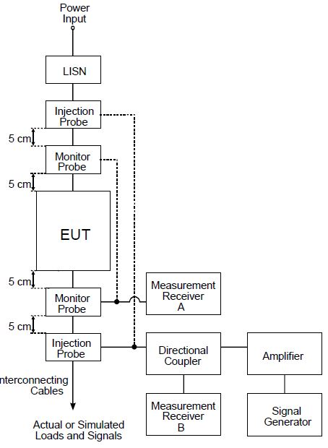

**Figure 10: CS114 Bulk Cable Injection**

**Final Measurements**

The equipment shall be visually examined and shall be electrically checked as specified and record the results in TDR-2

**8.4: CS115: Conducted Susceptibility, Bulk Cable Injection, Impulse Excitation.**

**CS115 Applicability:**

This requirement is applicable to all aircraft, space and ground system interconnecting cables, including power cables.

**CS115 Limit:**

The EUT shall not exhibit any malfunction, degradation of performance, or deviation from specified indications beyond the tolerances indicated in the individual equipment or subsystem specification, when subjected to a pre-calibrated signal having rise and fall times, pulse width, and amplitude as specified in Figure 11 at a 30 Hz rate for one minute.

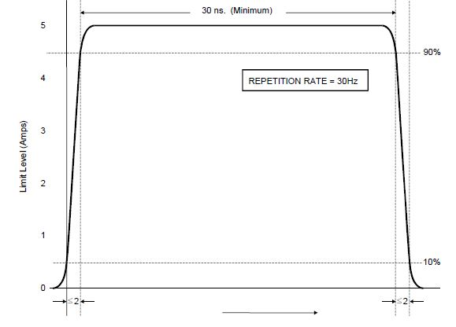

**Figure 11: CS115 Signal Characteristics**

**CS115 Test Procedure:**

a) Perform Calibration as per MIL-STD-461E (CS115) Requirements.

b) Turn on the EUT and allow a sufficient time for stabilization.

c) Susceptibility evaluation:

(i) Adjust the pulse generator, as a minimum, for the amplitude setting determined during calibration.

(ii) Apply the test signal at the pulse repetition rate and for the duration specified in the requirement.

(iii) Monitor the EUT for degradation of performance during testing.

(iv) Whenever susceptibility is noted, determine the threshold level and verify that it is above the limit.

(v) Record the peak current induced in the cable as indicated on the oscilloscope.

(vi) Repeat (i) through (v) on each cable bundle interfacing with each electrical connector on the EUT. For power cables, perform (i) through (v) on complete power cables (high sides and returns)and on the power cables with the power returns and chassis grounds (green wires) excluded from the cable bundle. For connectors which include both interconnecting leads and power, perform (i) through (v) on the entire bundle, on the power leads (including returns and grounds) grouped separately, and on the power leads grouped with the returns and grounds removed.

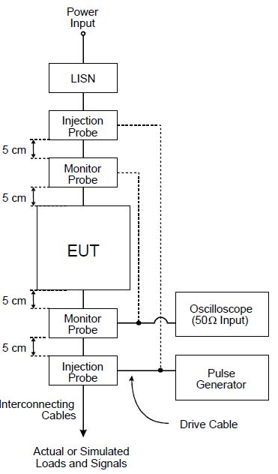

**Figure 12 : Typical Setup for CS115 Bulk Cable Injection**

**Final Measurements**

The equipment shall be visually examined and shall be electrically checked as specified and record the results in TDR-2

**8.5: CS116: Damped Sinusoidal Transients, Cables and Power Leads, 10 kHz to 100 Hz.**

**CS116 Applicability:**

This requirement is applicable to all interconnecting cables, including power cables and individual high side power leads. Power returns and neutrals need not be tested individually.

**CS116 Limit:**

The EUT shall not exhibit any malfunction, degradation of performance, or deviation from specified indications beyond the tolerances indicated in the individual equipment or subsystem specification, when subjected to a signal having the waveform shown in Figure 13 and having a maximum current as specified in Figure 14.

The limit is applicable across the entire specified frequency range. As a minimum, compliance shall be demonstrated at the following frequencies: 0.01, 0.1, 1, 10, 30, and 100 MHz. If there are other frequencies known to be critical to the equipment installation, such as platform resonances, compliance shall also be demonstrated at those frequencies. The test signal repetition rate shall be no greater than one pulse per second and no less than one pulse every two seconds. The pulses shall be applied for a period of five minutes.

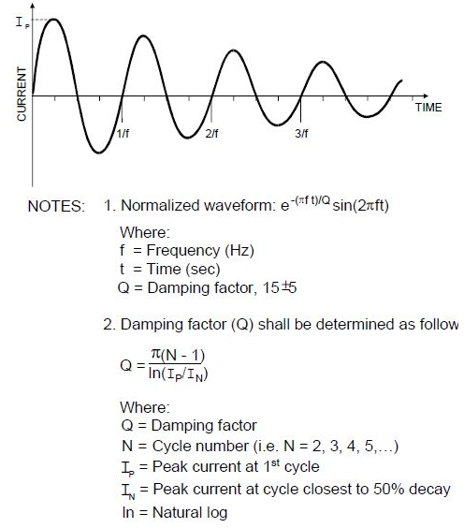

**Figure 13: Typical CS116 Damped Sinusoidal Waveform.** 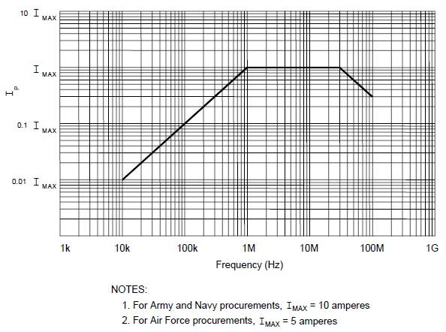

**Figure 14: CS116 Current Limit**.

**Final Measurements**

The equipment shall be visually examined and shall be electrically checked as specified and record the results in TDR-2

**CS116 Test Procedure :**

a) Perform Calibration as per MIL-STD-461E (CS116) Requirements.

b) Turn on the EUT and measurement equipment to allow sufficient time for

stabilization .

c) Set the damped sine generator to a test frequency.

d) Apply the test signals to each cable or power lead of the EUT sequentially. Slowly increase the damped sine-wave generator output level to provide the specified current, but not exceeding the pre-calibrated generator output level. Record the peak current obtained.

e) Monitor the EUT for degradation of performance.

f) If susceptibility is noted, determine the threshold level and verify that it is above the specified requirements.

g) Repeat (c) through (e) for each test frequency as specified in the requirement. Repeat testing for the power-off condition.

h) Perform the above procedures, using the EUT test setup on each cable bundle   
interfacing with each connector on the EUT including complete power cables. Also perform tests on each individual high side power lead (individual power returns and neutrals are not required to be tested).

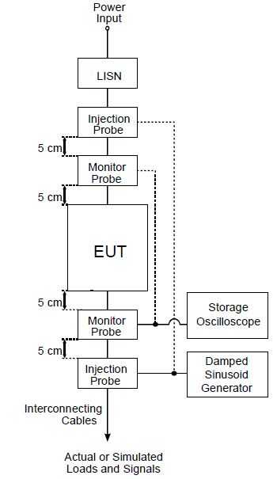

**Figure 15: Typical Setup for Bulk Cable Injection of Damped Sinusoidal Transients**

**Final Measurements**

The equipment shall be visually examined and shall be electrically checked as specified and record the results in TDR-2

**8.6: RE102 Radiated Emissions, Electric Field, 10KHz TO 18GHz.**

**RE102 Applicability:**

This requirement is applicable for radiated emissions from equipment and subsystem enclosures, all interconnecting cables, and antennas designed to be permanently mounted to EUTs (receivers and transmitters in standby mode). The requirement does not apply at the transmitter fundamental frequencies.

**RE102 Limit:**

Electric field emissions shall not be radiated in excess of that shown in Figure 3. Above

30 MHz, the limits shall be met for both horizontally and vertically polarized fields.

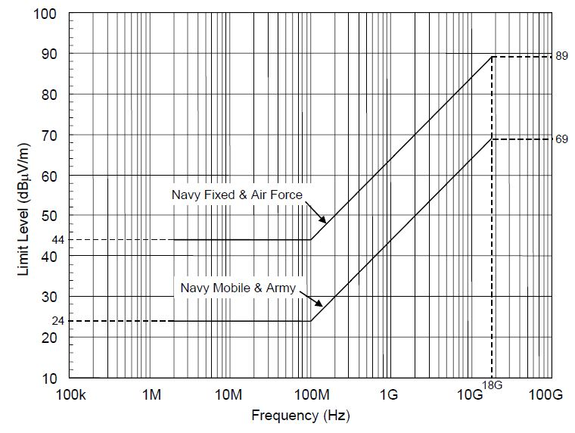

**Figure 3**: **RE102 Limit for Ground Applications**

**RE102 Test Procedure:**

a) Perform emission data scans using the measurement setup given in Figure 4 Ensure that the EUT is oriented such that the surface that produces the maximum radiated emissions is towards the front edge of the test setup boundary.

b) The Antenna Positioning should be done as indicated in Figure 5. The number of required antenna positions depends on the size of the test setup boundary and the number of enclosures included in the setup.Guidelines given in MIL-STD-461E, RE102 Requirements should be followed to determine the individual antenna positions.

c) Verify that the ambient is at least 6 dB below the allowable specified limits when the tests are performed in a shielded enclosure. Take plots of the ambient when required.

d) Perform Calibration as per MIL-STD-461E (RE102) Requirements

e) Turn on the EUT and allow a sufficient time for stabilization.

f) Using the measurement path of Figure.4, determine the radiated emissions from the EUT and its associated cabling.

g) Scan the measurement receiver for each applicable frequency range, using the bandwidths and minimum measurement times in Emission Test Parameters.

h) Above 30 MHz, orient the antennas for both horizontally and vertically polarized fields.

i) Take measurements for each antenna position determined above.

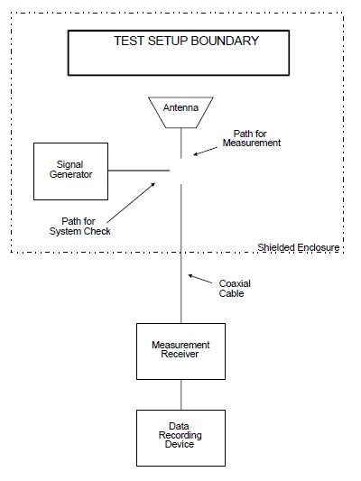

**Figure 4: RE102 Basic Test Setup**

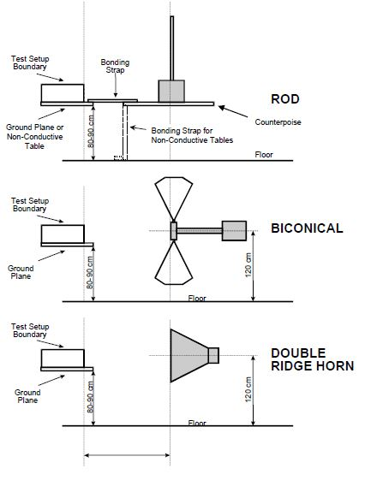

**Figure 5 Antenna Positioning**

**Final Measurements**

The equipment shall be visually examined and shall be electrically checked as specified and record the results in TDR-2

**8.7: RS103 Radiated Susceptibility, Electric Field, 2 MHz to 40 GHz.**

**RS103 Applicability:**

This requirement is applicable to equipment and subsystem enclosures and all interconnecting cables. The requirement at the tuned frequency of an antenna-connected receiver is 20 dB above the RE102 limit associated with the particular platform application.

**RS103 Limit:**

The EUT shall not exhibit any malfunction, degradation of performance, or deviation from specified indications, beyond the tolerances indicated in the individual equipment or subsystem specification, when subjected to the radiated electric fields of 50 V/m throughout the frequency range of 2 MHz to 40 GHz and modulated as specified below. Up to 30 MHz, the requirement shall be met for vertically polarized fields. Above 30 MHz, the requirement shall be met for both horizontally and vertically polarized fields. Circular polarized fields are not acceptable.

**RS103 Test Procedure:**

a) Maintain a basic setup as given in Figure 16. Electric field sensors are required from 2 MHz to 1 GHz. Either field sensors or receive antennas may be used above 1 GHz.   
b) The number of required antenna and sensor positions depends on the size of the test setup boundary and the frequency of radiation. Guidelines given in MIL-STD-461E, RS103 Requirements should be followed to determine the individual antenna and sensor positions.

c) Assess the test area for potential RF hazards and take necessary precautionary steps to assure safety of test personnel.

d) Perform Calibration as per MIL-STD-461E (RS103) Requirements

e) Turn on the EUT and allow a sufficient time for stabilization.

F) E-Field Sensor Procedure: As shown in Figure 16

(i) Set the signal source to 1 kHz pulse modulation, 50% duty cycle, and using

appropriate amplifier and transmit antenna, establish an electric field at the test start frequency. Gradually increase the electric field level until it reaches the applicable limit.

(ii) Scan the required frequency ranges in accordance with the rates and durations   
specified in Susceptibility Test Parameters. Maintain field strength levels in   
accordance with the applicable limit. Monitor EUT performance for susceptibility effects.

g) Receive Antenna Procedure:

(i) Remove the receive antenna and reposition the EUT in conformance with Figure 17.

(ii) Set the signal source to 1 kHz pulse modulation, 50% duty cycle. Using an appropriate amplifier and transmit antenna, establish an electric field at the test start frequency. Gradually increase the input power level until it corresponds to the applicable level recorded during the calibration routine.

(iii) Scan the required frequency range in accordance with the rates and duration's specified in Susceptibility Test Parameters while assuring the correct transmitter input power is adjusted in accordance with the calibration data collected. Constantly monitor the EUT for susceptibility conditions.

h) If susceptibility is noted, determine the threshold level and verify that it is above the limit.

i) Perform testing over the required frequency range with the transmit antenna vertically polarized. Repeat the testing above 30 MHz with the transmit antenna horizontally polarized.

j) Repeat the test procedures for each transmit antenna position required.

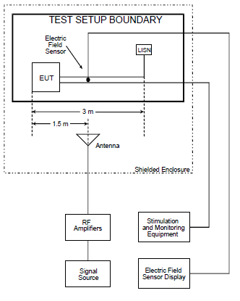

**Figure16:RS103 Basic Test Equipment Configuration(Using Sensor)**

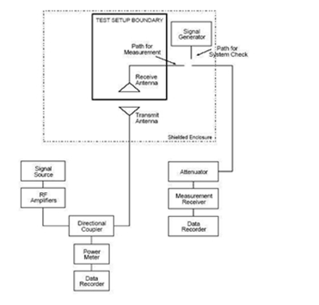

**Figure 17: RS103 Basic Test Equipment Configuration (Using Receive Antenna)**

**Recovery** - The equipment shall then be removed from the chamber and shall be restored to laboratory atmospheric conditions within 30 minutes for a period of 2 to 4 hours.

**Final Measurements**

The equipment shall be visually examined and shall be electrically checked as specified and record the results in TDR-2

**Physical Test Report - TDR-1 Date:**

**BEL Part No:** 4461 723 101 86

**Unit Serial Number:**

**PHYSICAL CHECK:**

|  |  |  |  |
| --- | --- | --- | --- |
| **S.NO** | **TEST** | **REQUIREMENT** | **RESULT** |
| 1 | 17RDKBDTdamages check | No damages | OK /NOT OK |
| 2 | Mating of circular connectors proper fitment | Proper fitment | OK /NOT OK |
| 3 | All the circular connectors assembled properly to the chassis | Proper assembly | OK /NOT OK |

**DIMENSIONAL CHECK:**

|  |  |  |  |  |
| --- | --- | --- | --- | --- |
| **S.NO** | **DESCRIPTION** | **SPECIFIED DIMENSIONS(MM)** | **MEASURED DIMENSIONS(MM)** | **RESULT** |
| 1 | Width | 482.6 ± 1.0 |  | OK /NOT OK |
| 2 | Height | 354.8 ± 1.0 |  | OK /NOT OK |
| 3 | Depth | 377 ± 2.0 |  | OK /NOT OK |
| 4 | Weight | ≤13 Kgs |  | OK /NOT OK |

**RESULT : OK / NOT OK**

**Remarks If Any :**

|  |  |
| --- | --- |
| **TESTED BY:** | **VERIFIED BY:** |
| **DESIGNATION:** | **DESIGNATION:** |
| **SIGN:** | **SIGN:** |

**Functional Test Report - TDR-2 Date:**

**BEL Part No:** 4461 723 101 86

**Unit Serial Number:**

|  |  |  |  |
| --- | --- | --- | --- |
| **S.No** | **Test** | **Requirement** | **Result** |
| 1 | **Fuctionality Of 17Rdkbdt:**  After switching ON the power to 17RDKBDT & TestPC check if the system got booted and display is seen on the screen of the unit. Set the required Resolution and check if the set resolution is supported and displayed on the screen | Resolution up to 1280 X 1024 | OK / NOT OK |
| 2 | **Functionality Of Keyboard / Trackball:**  After switching ON the power to 17RDKBDT & Test PC check the system gets booted and display is seen on the screen of the 17RDKBDT. Check the functionality of the keyboard by typing & functionality of Tracker Ball by Tracking or changing the position. | Test by pressing the keys on keyboard & check the same is displayed on the screen of the display.  To test the Tracker ball, Move the Tracker Ball & check if the cursor is moving in line to the  direction moved / Tracker ball is working fine. | OK / NOT OK |

**RESULT : OK / NOT OK**

**Remarks If Any :**

|  |  |
| --- | --- |
| **TESTED BY:** | **VERIFIED BY:** |
| **DESIGNATION:** | **DESIGNATION:** |
| **SIGN:** | **SIGN:** |